Name: ________________________________ Date:________

**Congruent Triangle Proofs Day 3 (CPCTC)**





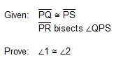

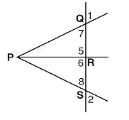

3.

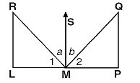

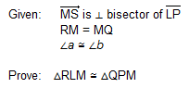

4.

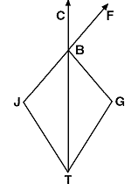

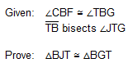



5.

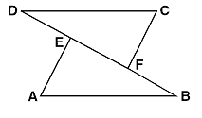

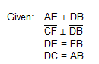

Prove: 

6.

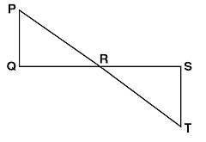

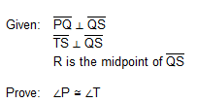

7.

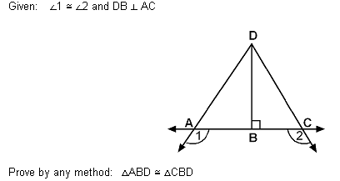

8. In the diagram below, four pairs of triangles are shown. Congruent corresponding parts are labeled in each pair.

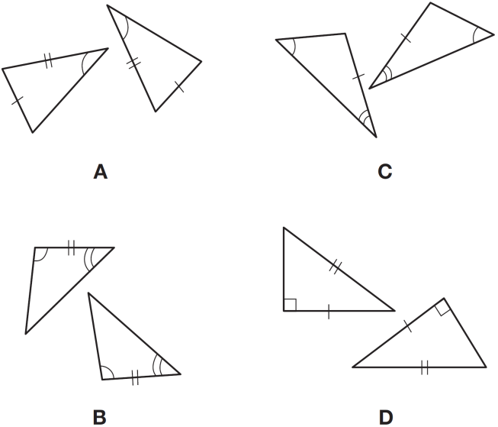

Using only the information given in the diagrams, which pair of triangles can *not* be proven congruent?

|  |  |
| --- | --- |
| 1) | *A* |
| 2) | *B* |
| 3) | *C* |
| 4) | *D* |

9. In the diagram below of  and , , and .

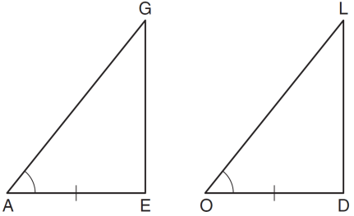

To prove that  and  are congruent by SAS, what other information is needed?

|  |  |
| --- | --- |
| 1) |  |
| 2) |  |
| 3) |  |
| 4) |  |

10. Which statements could be used to prove that  and  are congruent?

|  |  |
| --- | --- |
| 1) |  |
| 2) |  |
| 3) |  |
| 4) |  |

11. In  and , and . Write *one* additional statement that could be used to prove that the two triangles are congruent. State the method that would be used to prove that the triangles are congruent.